The best recommended approach to update policies in ServiceNow when changes occur in GitHub is to use ServiceNow Integration Hub combined with a GitHub Webhook.
This event-driven architecture ensures that any time a policy file is modified, merged, or approved in GitHub, ServiceNow is instantly notified and updates its records automatically.
Recommended Integration Architecture
Webhook on Pull Request/Push)--> [ ServiceNow Scripted REST API ] │ ▼ [ ServiceNow Integration Hub ] │ ▼ [ ServiceNow Policy [sn_compliance_policy] Table ]
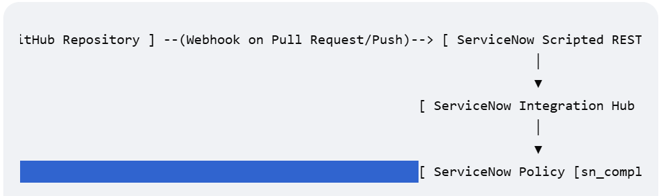

Step-by-Step Implementation Guide
1. Configure the ServiceNow Inbound Endpoint
Instead of polling GitHub for changes, set up an endpoint in ServiceNow to listen for GitHub events.
- Create a Scripted REST API in ServiceNow to serve as your webhook listener.
- Define a POST resource (e.g., /api/snc/github_policy_sync).
- Configure the API to require Basic Auth or an API Token, which you will share with GitHub. [1, 2, 3, 4, 5]
Set Up the GitHub Webhook [1]
Trigger the sync automatically whenever your policy files change.
- Go to your GitHub Repository -> Settings -> Webhooks -> Add webhook.
- Payload URL: Enter your ServiceNow Scripted REST API endpoint URL.
- Content type: Select application/json.
- Secret: Add a secure string to validate that incoming payloads genuinely originate from your GitHub repository.
- Events: Choose Just the push event or Pull requests (depending on whether you want to sync on every main branch commit or only when code is merged)
Parse Payload and Route via Integration Hub
When GitHub sends the JSON payload, your ServiceNow Scripted REST API script will process it.
- Verify Secret: Validate the X-Hub-Signature-256 header using your secret key.
- Extract Data: Parse the commit or PR data to find which policy files (.md, .json, or .txt) were modified.
- Trigger Action: Pass the file path and content to a custom Integration Hub Action or Flow Designer flow.
Update the ServiceNow Policy Table
Use Flow Designer to safely update your GRC/Compliance records.
- Use the GitHub Spoke (available in Integration Hub) if you need to fetch the full raw file content directly from the GitHub API using the file path.
- Look up the corresponding record in the Policy [sn_compliance_policy] table (often matching GitHub file name to the Policy Name or ID).
- If the record exists, Update the policy text or state field.
- If the record does not exist, Create a new policy record and route it for internal ServiceNow approval if required.
Alternative Approach: ServiceNow DevOps Spoke
If your policies are tied directly to software development compliance or deployment pipelines:
- Use the official ServiceNow DevOps Spoke.
- This out-of-the-box spoke automatically tracks GitHub commits and pull requests, mapping them directly to DevOps data models inside ServiceNow without custom API coding

